Event 1998.11.22 – (1998-326)

Particle event: To(Ep>10 MeV) – 22d07^{h}
Tmax₁(Ep>10 MeV) – 22d09^{h}, Jmax₁ (Ep>10 MeV) – 1.1 /cm².s.sr
Tmax₂(Ep>10 MeV) – 22d14^{h}, Jmax₂ (Ep>10 MeV) – 0.6 /cm².s.sr
Duration of the event – 1.5 day
Energy of the SCR and 0.1 GCR fluxes balance – Eb(max₁) = 285 MeV
– Eb(max₂) = 160 MeV

Sources: ● solar flare 22d06^{h}30^{m}, X3.7/1N, S27W82, AR8384
Main burst X-ray 1-8 Ǻ: onset – 22d06^{h}30^{m}, max – 22d06^{h} 42^{m}, Ф = 0.2 J/m²
CME: gap

Particle fluxes and associated phenomena
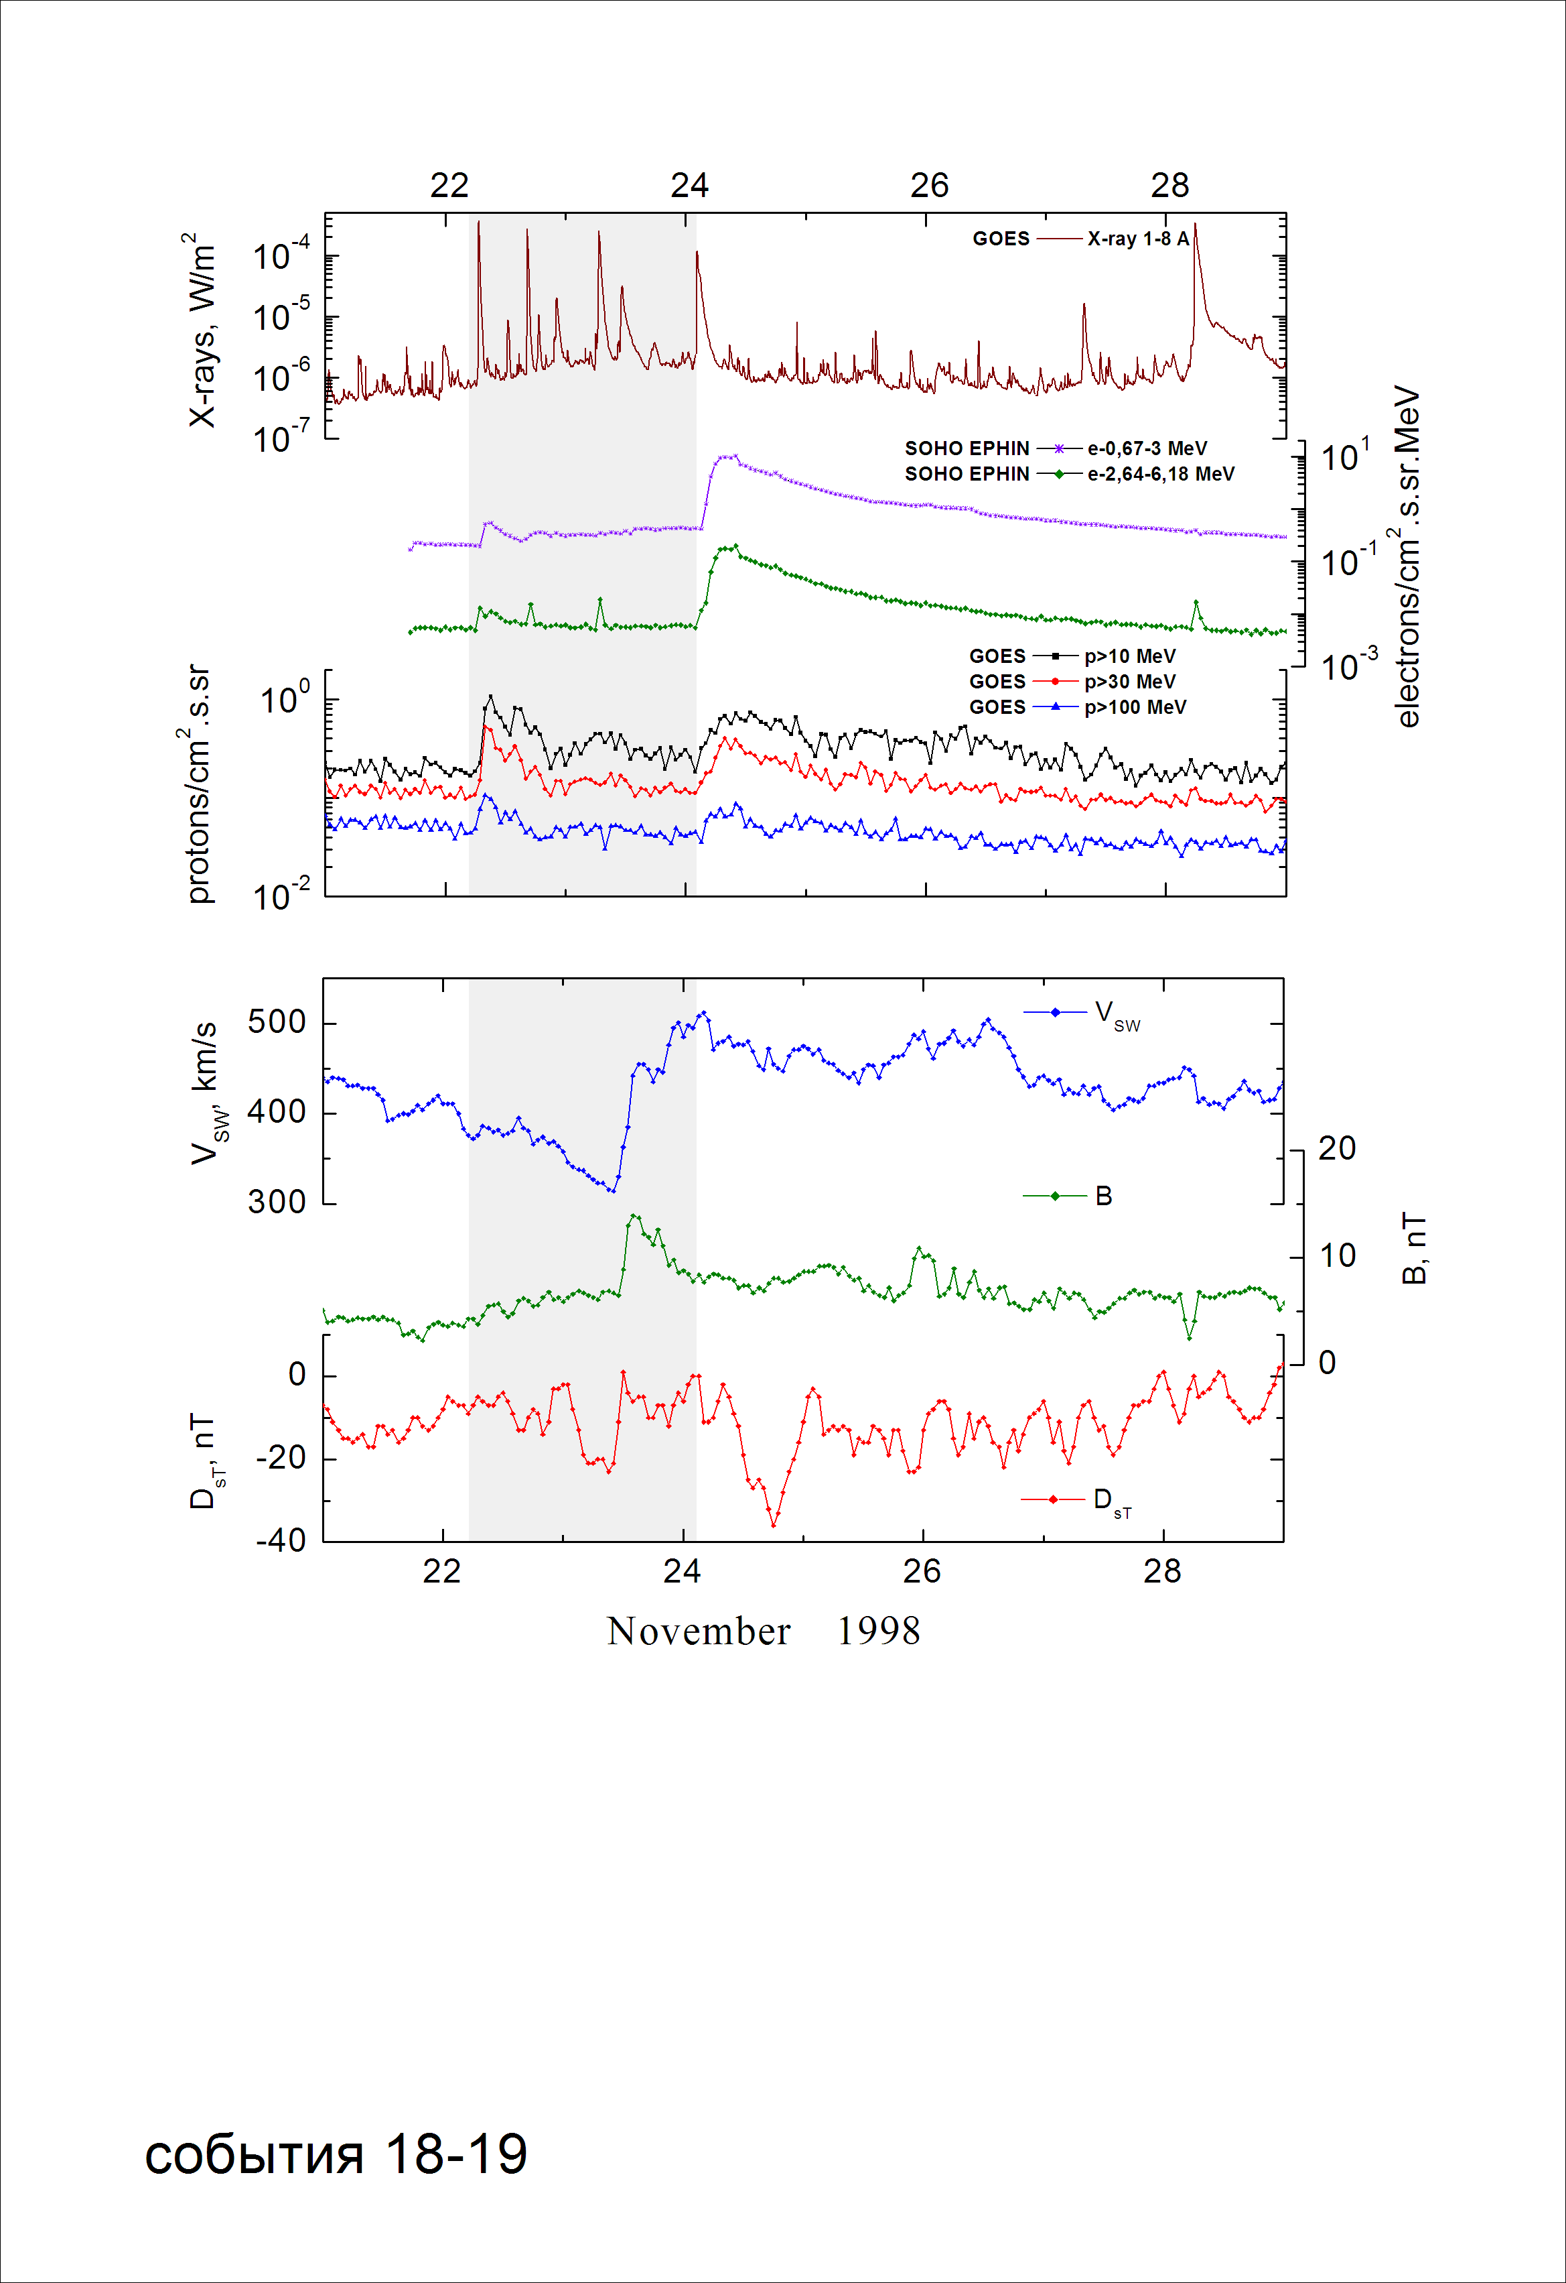
Integral time-of-maximum proton spectrum
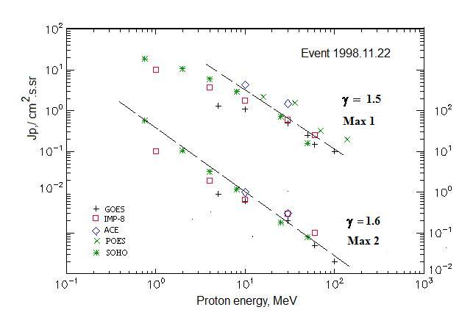

Integral fluxes of protons for the event of 1998 November 22

S/c, instruments | Eр, MeV | To | Tmax | Jmax,  /cm².s.sr | Dura-tion | Comments
GOES-10
EPS | >5 | 07^{h} | 09^{h}/14^{h} | 1.33/0.9 | 1d
EPS | >10 | 07^{h} | 09^{h}/14^{h} | 1.1/0.6 | 1d
EPS | >30 | 07^{h} | 08^{h}/13^{h} | 0.5/0.2 | 1d
EPS | >50 | 07^{h} | 08^{h}/13^{h} | 0.25/0.08 | -
EPS | >60 | 07^{h} | 08^{h}/13^{h} | 0.15/0.05 | -
EPS | >100 | 07^{h} | 08^{h}/13^{h} | 0.1/0.02 | -
POES-15
MEPED | >0.24 | - | - | - | -
MEPED | >0.8 | - | - | - | -
MEPED | >2.5 | - | - | - | -
MEPED | >6.9 | - | - | - | -
MEPED | >16 | - | 08^{h}/ - | 2.2/ - | -
MEPED | >36 | - | 08^{h}/ - | 1.6/ - | -
MEPED | >70 | - | 08^{h}/ - | 0.33/ - | -
MEPED | >140 | - | 08^{h}/ - | 0.2/ - | -
IMP-8
CPME | >1 | 07 ^{h} | 12^{h}/16^{h} | 10/10.3 | 2d
CPME | >4 | 07 ^{h} | 10^{h}/16^{h} | 3.8/1.9 | 2d
CPME | >10 | 07 ^{h} | 09 ^{h}/16^{h} | 1.8/0.65 | 1,5d
CPME | >30 | 07 ^{h} | 09^{h}/16^{h} | 0.6/0.3 | 1d
CPME | >60 | 07 ^{h} | 09^{h}/16^{h} | 0.25/0.1 | 1d
ACE
SIS | >10 | 07 ^{h} | 09^{h}/16^{h} | 4.3/1.0 | 2d
SIS | >30 | 07 ^{h} | 08^{h}/16^{h} | 1.5/0.3 | 2d
SOHO
EPHIN (INT) | >50 | 07^{h} | 08^{h}/17^{h} | 0.16/0.08

Differential fluxes of protons for the event of 1998 November 22

S/c, instruments | ∆Е, MeV | To | Tmax | Jmax. /cm².s.sr.MeV | Dura-tion | Comments
IMP-8
CPME | 1-2 | 08^{h} | 12^{h}/18^{h} | 4/6 | ∼2d
CPME | 2-4.6 | 07^{h} | 12^{h}/18^{h} | 1.4/1.3 | ∼2d
CPME | 4.6-15 | 07^{h} | 10^{h}/18^{h} | 0.2/0.1 | ∼2d
CPME | 15-25 | 07^{h} | 109^{h}/18^{h} | 0.08/0.025 | ∼2d
CPME | 25-48 | 07^{h} | 09^{h}/19^{h} | 0.021/0.009 | ∼2d
CPME | 48-96 | 07^{h} | 09^{h}/ - | 0.006/ - | ∼1d
CPME | 96-145 | 06^{h} | 09^{h}/ - | 0.004/ - | ∼1d
CPME | 145-440
SOHO
LION | 0,75-2 | 07^{h} | 10^{h}/19^{h} | 6.5/27 | ∼1d
LION | 2-6 | 07^{h} | 11^{h}/19^{h} | 1.2/1.8 | ∼1d
EPHIN | 4-8 | 08^{h} | 10^{h}/17^{h} | 0.75/0.5 | ∼1d
EPHIN | 8-25 | 07^{h} | 09^{h}/17^{h} | 0.13/0.06 | ∼1d
EPHIN | 25-41 | 07^{h} | 08^{h}/17^{h} | 0.02/0.005 | ∼1d
EPHIN | 41-53 | - “ - | - “ - | - “ - | - “ -

References
No information on publications, excepting for:
http://www.swpc.noaa.gov/ftpdir/indices/SPE.txt

